CURRICULAM – VITAE 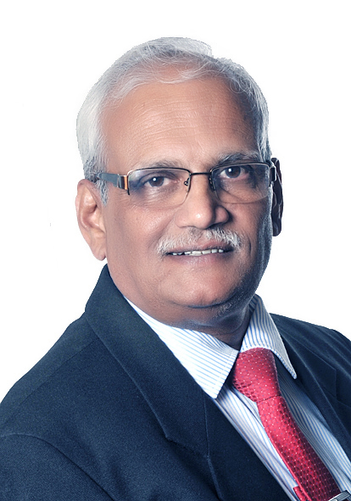

- Name: Commander Narayan L Kulkarni (Ret’d)
- Date of Birth: 11th May 1955
- Address: # 203, “NAMAN”, 4th “B” Cross, 2nd “A” Main, Kasturi Nagar, East of NGEF, Bangalore - 560043
- Telephone: 080-25426767 (Land), +919880825277 (Mobile)
- Email-Id: naman_203@hotmail.com and naman203@gmail.com
- Passport Number: K 8365122 (Valid till 4th Dec 2022)
- Qualifications:
  - BE (Mechanical) from Karnataka University in 1977 (3rd Rank).
  - Marine Engineering from Naval College of Engineering, Lonavla in 1978.
  - M Sc (Defence Studies) from Madras University (DSSC, Wellington), in 1990.
  - PG Diploma in Marketing Mgt from Mumbai University (JBIMS), in 1993 (2nd Rank).
  - Quality Assurance Certificate Course from DIQA, Bangalore during 2001.
- Employment & Experience:
- Indian Navy: Joined in Marine Engineering Branch of Indian Navy on 15th Aug 1977 as Lieutenant and took voluntary retirement on 30th Apr 2004 in the rank of Commander, with key appointments as under:

- INS Shakti: Sep 1977 to Feb 1978 (Watchkeeping Certificate)
- INS Amba: Aug 1978 to Oct 1979 (Duties in Engineering Department)
- MS, Vizag: Nov 1979 to May 1983 (Assistant Controller of Material Planning)
- WOT, Goa: Jun 1983 to Sep 1986 (SNEO)
- INS Kakinada: Oct 1986 to May 1988 (EO)
- INS Karwar: May 1988 to May 1989 (EO)
- DSSC, Wellington: Jun 1989 to May 1990 (psc course, Staff College)
- HQWNC: May 1990 to Jun 1994 (CRO)
- INS Deepak: Jun 1994 to Jul 1995 (EO)
- NHQ: Jul 1995 to Oct 1998 (DFM)
- QAE (WE), Bangalore: Oct 1998 to Apr 2004 (QAO & O i/c)

- Major Experiences gained during above appointments are enumerated below:

- Operation & Maintenance of Propulsion, Power Generation / Distribution and Auxiliary Equipment onboard Warships, including keeping alive Propulsion & Power generation in frozen sea with innovative methods, as commissioning EO onboard INS Kakinada.
- Inventory Management of Equipment/Spares for Warships / Submarines at CMP, Vizag.
- Warship Construction Overseeing of Marine Engineering and Power Generation / Distribution Equipment including Documentation, for nearly 25 warships (LSTs, SDBs, Survey Ships & TRVs etc) including detection of fault in propellers supplied by MTU while doing astern mode onboard SDBs leading to free replacement by suppliers for three ships each in GSL, Goa and GRSE, Kolkata as SNEO at WOT, Goa.
- Planning / Scheduling / Monitoring of Refits / Modernization of Warships / Submarines by Naval Dockyards / Shipyards, for nearly 200 ships and submarines, including Aircraft Carriers, as CRO/HQWNC and DDFM/NHQ.
- Head of Quality Assurance for Karnataka & Kerala in Bangalore under DGQA for Engineering / Electrical Equipment with stringent QAPs for Warships & Submarines of “Indian Navy”, including Project ATV. Responsible for QA coverage in Kerala & Karnataka, including 25 MW GTs of HAL, One MW Steam Turbines of Triveni & HAL and one MW Generators of Kirloskar.

- Haden IFM: Facility Manager at Sasken, Bangalore.
- Garuda Mall: General Manager, Facilities Management at Garuda Mall.
- Abhiruchi Foods: General Manager at Abhiruchi Foods.
- Cushman & Wakefield: Joined C&W in Facilities & Properties Management division on 14th May 2007 till 31st May 2015 (with last two years as full time consultant) with various positions held as under:
- Operations Manager for FM Sites in Bangalore from 14th may 2007 to Dec 2008.
- Associate Director, Operations (Pan India) from Jan 2009 to March 2010.
- Associate Director, Process, Engineering & Transition (Pan India), from Apr 2010 to March 2012
- Associate Director, Process, Quality &Training (Pan India), from Apr 2012 till Dec 2013.
- Associate Director, Learning & Development (Pan India) from Jan 2014 to May 2015.

- Major Achievements:

Indian Navy
---------------

- Commendation by FOC-in-C, West for diligent duties as CRO, HQWNC
- Free replacement of Propellers by suppliers for SDB Class Ships built by GSL and GRSE, as defect of deformation during astern mode was detected by me, with nearly 18 dockings of first ship of the class at GSL, as SNEO at WOT, Goa.
- Keeping alive Propulsion & Power generation in frozen sea with innovative methods and also fighting a major fire, off Gulf of Riga, as commissioning EO onboard INS Kakinada
- Planning, Scheduling and coordinating for smooth conduct of Mid-Year and Annual Refit Conferences to ensure timely completion of major refits including modernization and refits offloaded to Shipyards, apart from seeking financial approval from MOD for the expenses, as DDFM, NHQ.
- Drafted two important Navy Orders pertaining to Refits of Ships and Submarines and Cannibalization of Spares, as DDFM/NHQ and eventually promulgated.
- Quality Assurance of Steam Turbines (for Project ATV) at Triveni, 25 MW Gas Turbines at HAL and One MW Generators at Kirloskar, as QAO, QAE (WE), Bangalore.

Facilities Management
-----------------------------

- Facilities & Property Management Operations on Pan India Basis
- Evolved nearly 30 SOPs pertaining to Facilities & Property Management
- Evolved nearly 40 Training Modules pertaining to Facilities & Property Management
- Successfully carried out Transition Management pertaining to Facilities & Property Management

Place: Bangalore
Date: 20th Oct 2015 Cdr (Ret’d) Narayan Kulkarni

“When the Going Gets Tough, The Tough Gets Going”

